Theory of Programming Language

2021

Assignment #01

Calendar program on java

***Calendar program Code:***

public class Calendar {

public static void main(String[] args) {

int Y = 2021; // year

int startDayOfMonth = 5;

int spaces = startDayOfMonth;

String[] months = {

"",

"January", "February", "March",

"April", "May", "June",

"July", "August", "September",

"October", "November", "December"

};

int[] days = {

0, 31, 28, 31, 30, 31, 30, 31, 31, 30, 31, 30, 31

};

for (int M = 1; M <= 12; M++) {

if ((((Y % 4 == 0) && (Y % 100 != 0)) || (Y % 400 == 0)) && M == 2)

days[M] = 29;

System.out.println(" "+ months[M] + " " + Y);

// Display the lines

System.out.println("-------------------------------------");

System.out.println(" Sun Mon Tue Wed Thr Fri Sat");

// spaces required

spaces = (days[M-1] + spaces)%7;

// print the calendar data

for (int i = 0; i < spaces; i++)

System.out.print(" ");

for (int i = 1; i <= days[M]; i++) {

System.out.printf(" %3d ", i);

if (((i + spaces) % 7 == 0) || (i == days[M])) System.out.println();

}

System.out.println();

System.out.println("Calender By ABDUL RAFEH CSC@20s104");

}

}

}

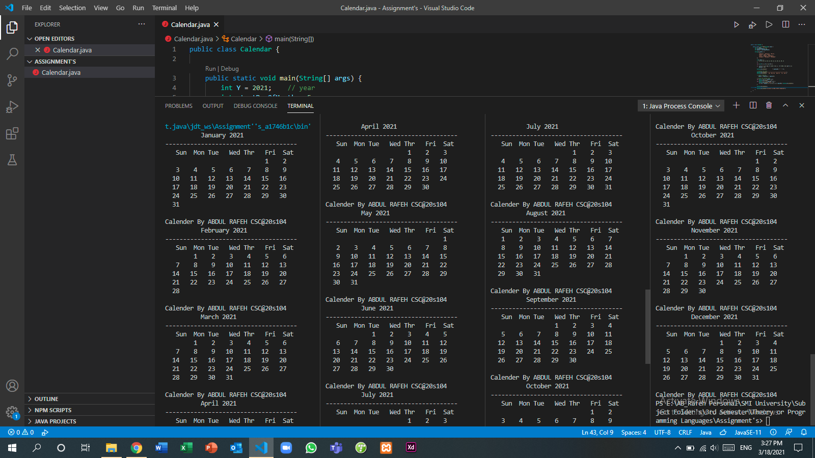***Output Screenshot:***